**Midterm Graphs and Answers**

Problem 1, Part e)

As the random sample size increases, the proportion of random samples which are equal to “H” (heads) becomes closer to 0.5, which is equivalent to ½ or 50%. (For 10 samples the proportion is 0.2, for 100 samples the proportion is 0.44 and for 10000 samples the proportion is 0.4915.) This makes sense as we would expect a coin flip to have an even chance of being heads or tails.

Problem 1, Part g)

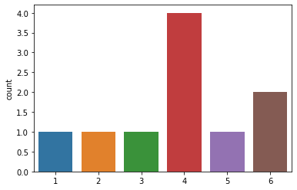

Problem 1, Part h)

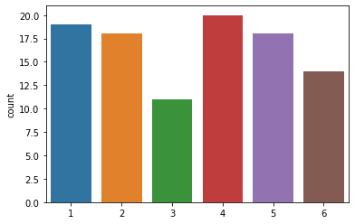

Problem 1, Part i)

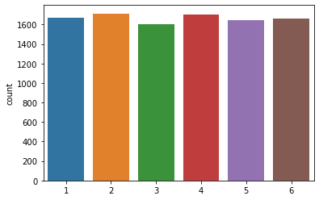

Problem 1, Part j)

As we increase the number of times of rolling a dice, the count of each number becomes more similar to all other number counts. This makes sense as we would expect each number to have the same probability of being rolled.

Problem 2, Part b)

There appears to be a weak negative linear correlation of about -0.1094 between sepal_width and sepal_length.

Problem 2, part c)

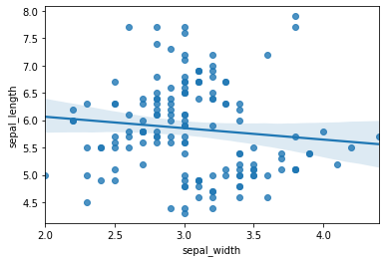

Problem 2, Part d)

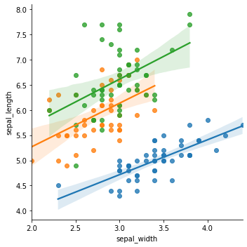

Problem 2, Part e)

The pearson correlation for each individual species is as follows:

* Setosa: 0.7468
* Versicolor: 0.5259
* Virginica: 0.4572

Problem 2, Part f)

Since the pearson correlation for each individual species-setosa, versicolor and virginica-between sepal_width and sepal_length all reveal a positive linear correlation (0.7468, 0.5259 and 0.4572, respectively), it appears Dr. Lee is correct in thinking Simpson’s paradox has occurred and that the relationship between sepal_width and sepal_length is indeed a positive linear correlation.

Problem 3, Part b)

There are 885,548 observations in the unemp dataset.

Problem 3, Part d)

There are no missing values in the unemp dataset.

Problem 3, Part f)

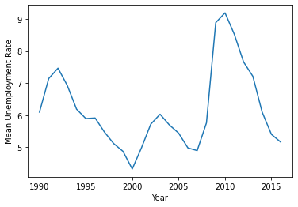

Problem 3, Part h)

The top five counties with the lowest unemployment rate in Michigan in January 2016 are Washtenaw County (rate: 2.9), Kent County (rate: 3.1), Ottawa County (rate: 3.1), Kalamazoo County (rate: 3.5) and Saint Joseph County (rate: 3.7).

Problem 3, Part j)

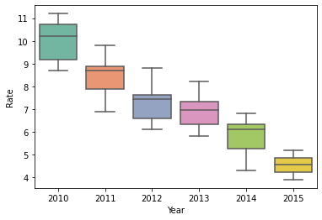

It appears as though the unemployment rate in Kalamazoo County, Michigan has been decreasing from 2010 to 2015!